
LEDTask™ LTR300-, LTR60, GM100, GM300, GM60 series 12VDC an 24VDC , 30m , 5m and 1 Meter Reel Ribbon Installation Instructions using LTC and LTW- connectors

*MAKE SURE LEDTask AMPERAGE DOESN’T EXCEED POWER SUPPLY*

***ONLY USE the proper 12VDC or 24VDC VOLT POWER SUPPLIES***

Make all connections and test system before installing
MAX RUN ON A SINGLE POWER LEAD high output-= 16.4 FEET std output- = 32 feet

- Cutting the LED ribbon to desired length: Using scissors the LED ribbon can be cut on the clearly marked cutting line which is located every 3/6 LEDS except where the solder drops are located on the ribbon. The solder is located every 19-1/2 inches on the ribbon. Making a cut outside the cut area will cause damage to that circuit and the ribbon will not operate properly.
- Connecting ribbon to power supply. Using the LTW- connector, Pull the wedge out, slide the ribbon into the crimp connector, making sure to fully insert the copper contacts into the connector. Verify the polarity is correct. Test connection for continuity and polarity, slide the wedge in tightly until it seats fully.
- Connecting cut ribbon sections together. Using the LTC- at end of the ribbon, slide the second ribbon into the connector. Make sure the copper contact points are fully in the connector. It may be necessary to trim the ribbon end place the contact points fully in the connector. Test connection for continuity; push the wedge in squarely and tightly.
- Make sure to verify polarity, continuity, and the LTC connector and ribbon have a proper electrical orientation. The connector cannot be “flipped” or put on upside down. The connector only makes continuity right side up, If polarity is not correct make sure the connector or ribbon is in the correct end for end orientation.

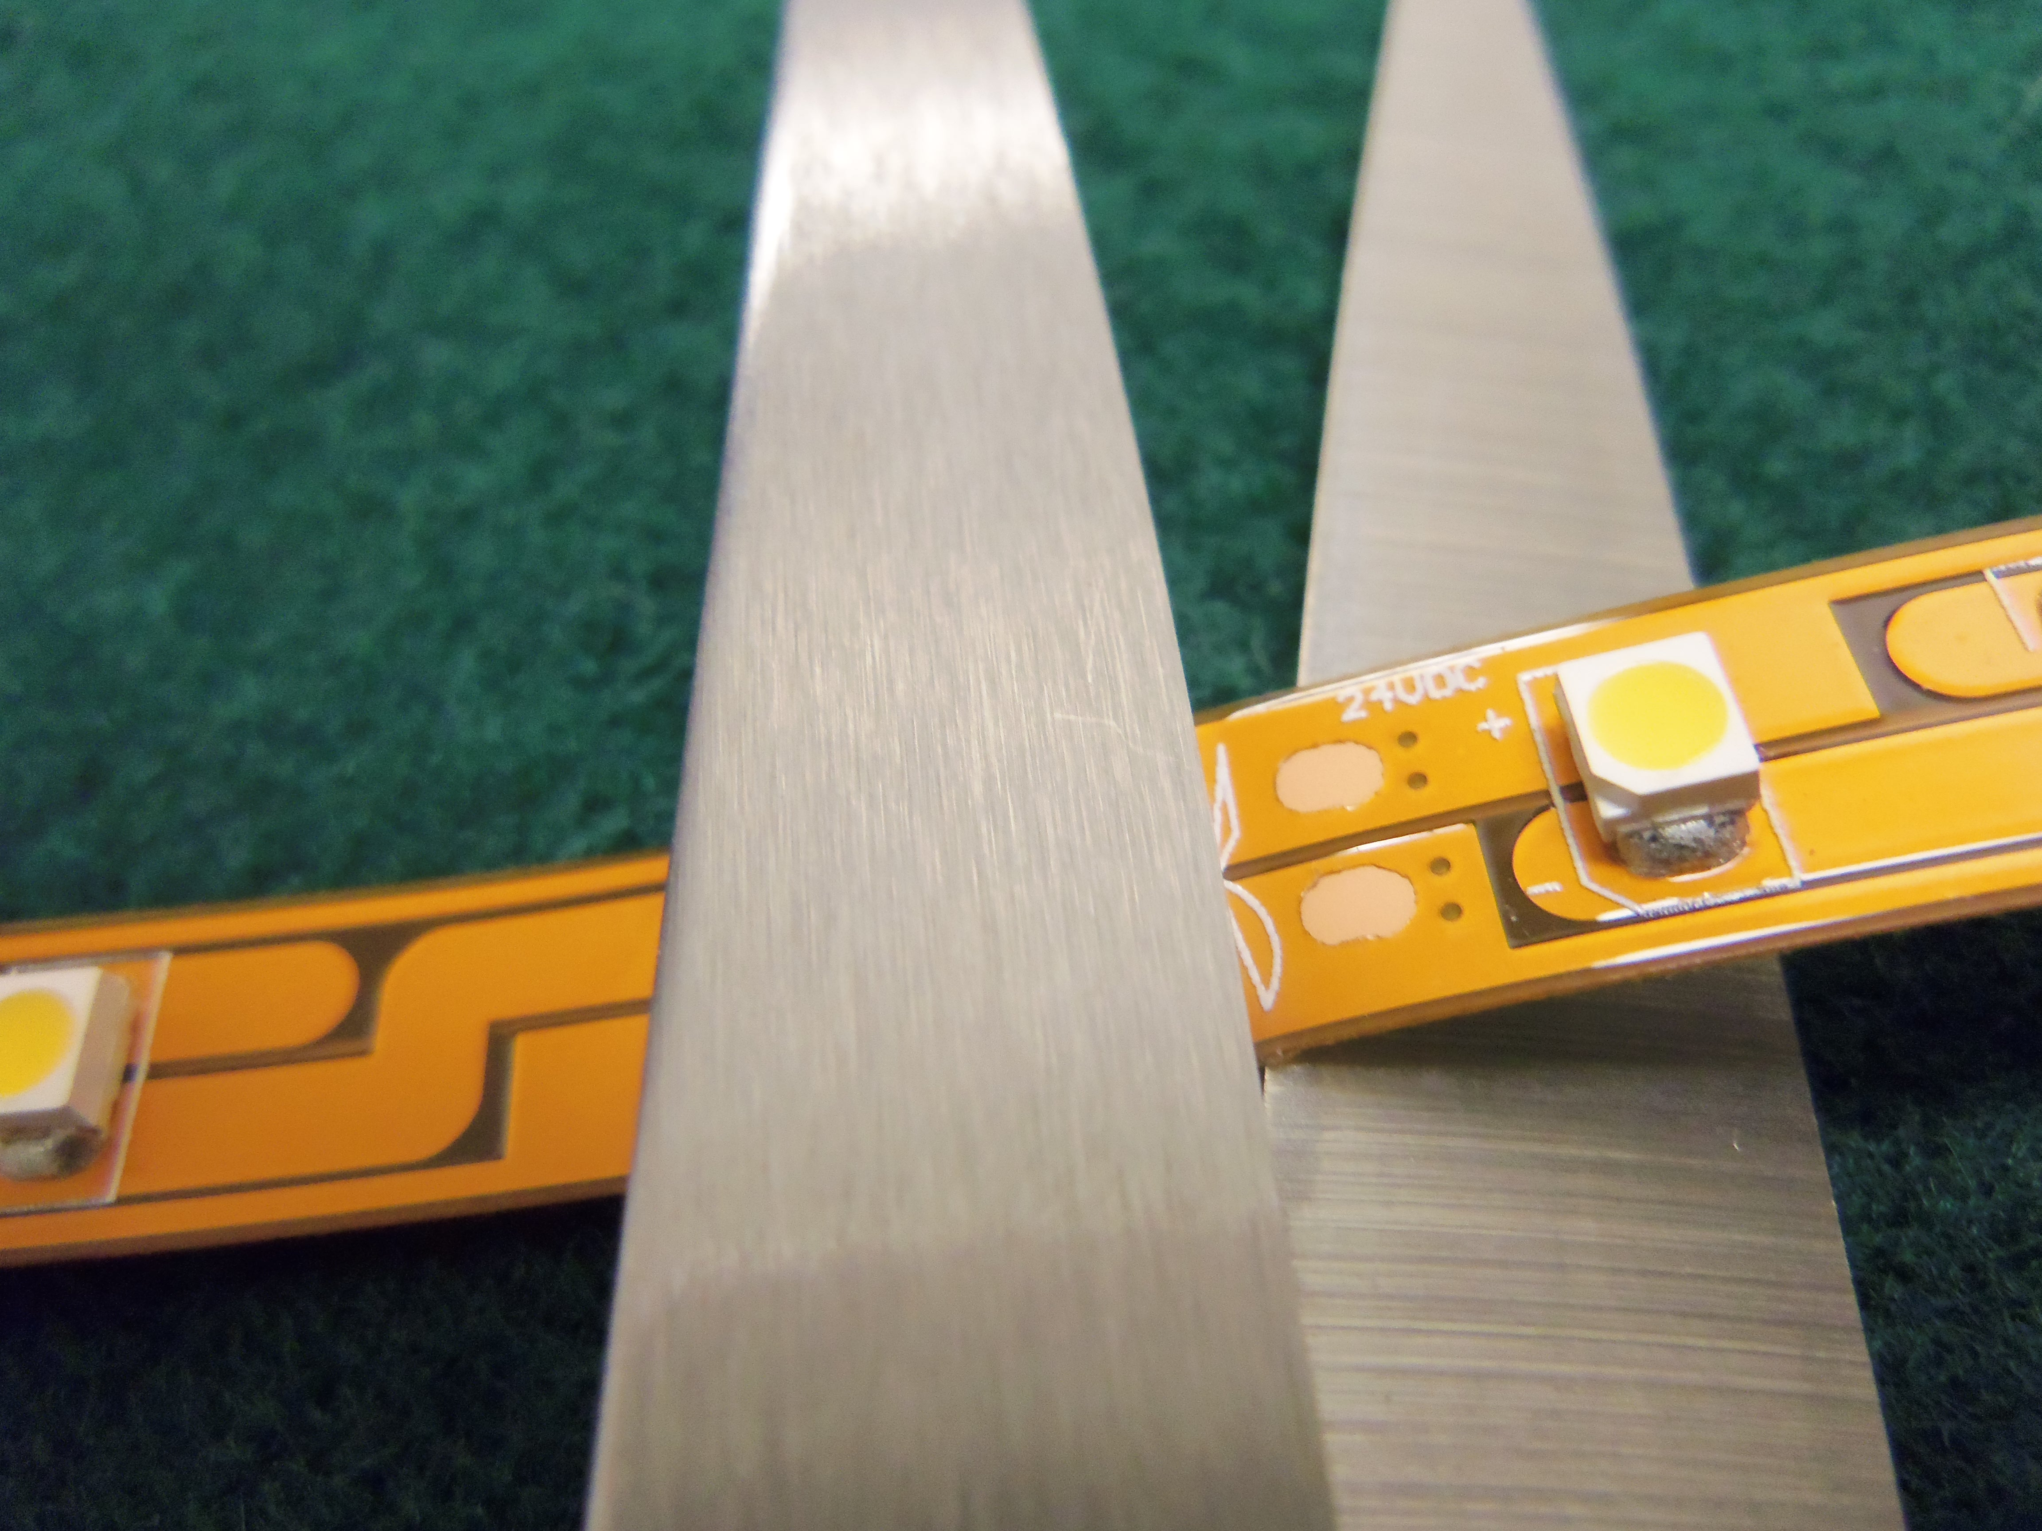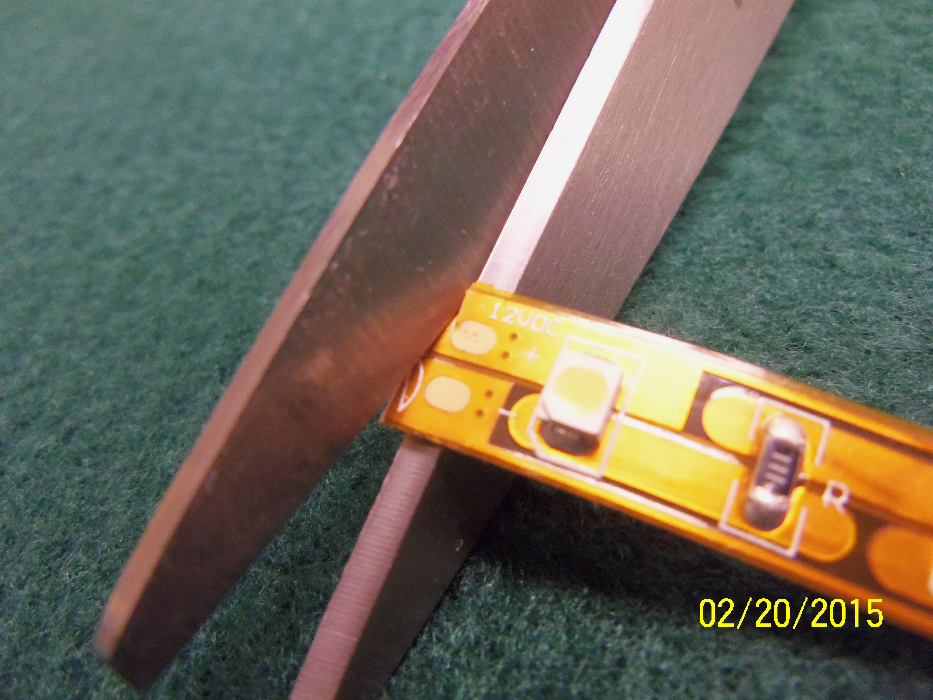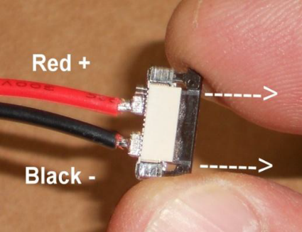

Cut ribbon in designated areas. It may be necessary to trim end of ribbon to facilitate greater conductor contact.
The copper contact points need to be fully inserted in the connector.

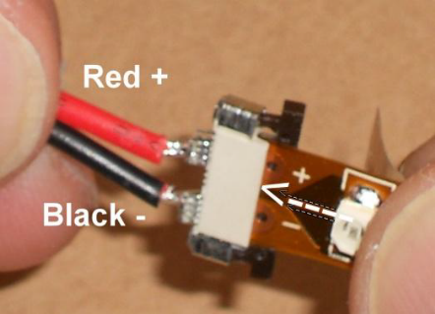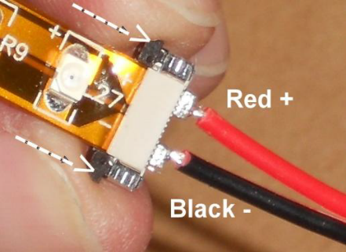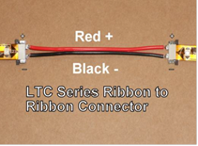

Align polarities and slide ribbon into connector and seat ribbon in fully and push the wedge in fully.
(LTC-12”,) ribbon to ribbon

